Project_Colorize

- In this project you will color or re-color an image.
- Click on the link and watch the video:
  - https://youtu.be/jn2k5b5mwEs
  - https://youtu.be/VEfXy8i-yLs
  - https://youtu.be/35hhu6UBRvU
    - Pause and rewind the video as needed.
- Download or upload a picture to colorize
  - Upload a drawing you have made
    - You can take a picture of the drawing or scan it
  - Download a picture from the internet
    - For your first attempt find a picture that is not that complex.
      - Easy pictures that you could start with are
        - Coloring pages
        - Anime or manga
        - Cartoons
        - Vector art
- Open Inkscape.
  - Insert the picture you want to color into Inkscape
    - If you are copying from the internet you can just copy and paste
      - Ctrl + C, then Ctrl + V, into Inkscape
      - If it does not work you may have to download the picture and insert it.
    - To insert a picture:
      - File > Insert
        - 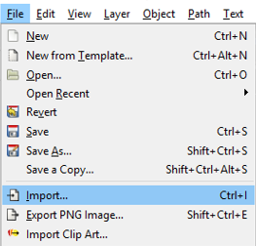
  - Name the layer your picture is on and lock it.
  - Create a new layer above the drawing and name it.
  - Use the Pen Tool, Fill and Stroke Pallet, and Inkdropper to complete your re-color
- The project must include
  - Nicely done re-color
  - 2 or more layers
  - Good use of color
- Name you file the following:
  - Class_firstname_lastname_Colorize
- Project Grade
    - 25 points for naming the project correctly
    - 75 for including all the required elements.
- Raise your hand when complete.

