18_Layers

- Click on the link and watch the video:
  - https://www.youtube.com/watch?v=7BjypaPjbZs&index=18&list=PLs-a95_rRZCfT64ICoIjaK4gzzbIpyt3T
- The template named: 18_Layers_Template
  - Use the layers menu to make the template look like the following example: 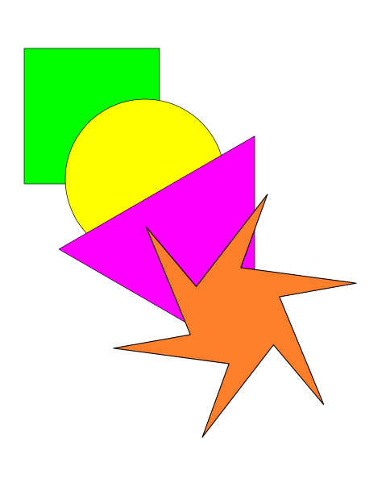
- Below is some extra pointers to help you out.
Layer you are on, you can rename it.
Add or delete layers.
These move layers up and down.
The eye makes the layer visible.
The lock, makes the layer un-editable.
. 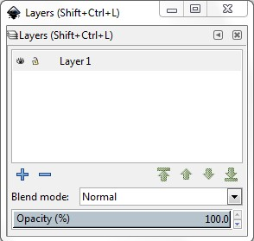

- After you have completed the project, save the file in YOUR inkscape folder.
  - Name the file: class_firstname_lastname_Layers
- This is a Graded assignment
  - Daily grade
    - 50 points for following the directions.
    - 50 points for naming the file and folder correctly
- When complete raise your hand.

