17_Text Tool

- Click on the link and watch the video:
  - https://www.youtube.com/watch?v=0NFFhil9Dyo&index=17&list=PLs-a95_rRZCfT64ICoIjaK4gzzbIpyt3T
- Open Inkscape.
- Use the text tool to and the following steps to create some text.
  - First name: Arial, Normal, size 48
  - Last name: Centaur, Normal, Size 48
  - Your favorite color: Times New, Italic, Size 56, turn it to the color you wrote.
  - Your favorite food: Old English Text MT, Normal, Size 64
  - Your favorite super hero: Tahoma, Bold, size 72, Character roation 15
- Your completed work should look similar to this:
  - 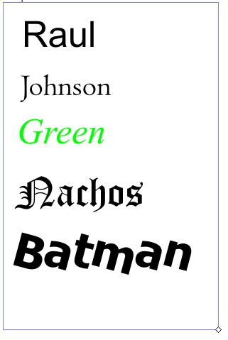
- After you have completed the project, save the file in YOUR inkscape folder.
  - Name the file: class_firstname_lastname_text
- This is a Graded assignment
  - Daily grade
    - 50 points for following the directions.
    - 50 points for naming the file and folder correctly
- When complete raise your hand.

