13_Stroke

- Click the link and watch the video:
  - https://www.youtube.com/watch?v=heNUstY7ez8&index=13&list=PLs-a95_rRZCfT64ICoIjaK4gzzbIpyt3T
- You can open the stroke dialog several different ways.
  - Quick key: Shift+Ctrl+f
  - Dropdown: object>fill and stroke
  - Double click the color example in the bottom right corner.
- The stroke color dialog looks like this:
  - 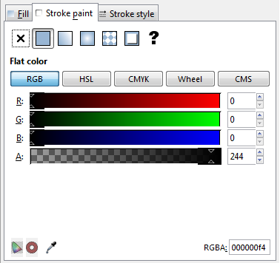
  - You can use the sliders to adjust the colors.
  - You can use the color picker to select colors.
    - 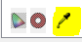
- The stroke style dialog looks like this:
  - 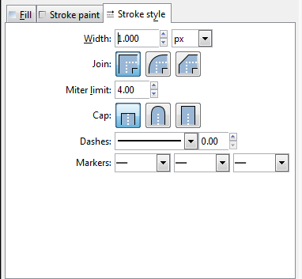
  - You can adjust the size of the stroke with this slider:
  - These buttons change the corners of the stroke:
  - This dropdown changes the type of stroke.
- In Inkscape open the Template: 15_stroke_temp
- Use the stroke pallet to make the template look like this one:
- After you have completed your shapes, save the file in your Inkscape folder.
  - Name the file: class_firstname_lastname_stroke
- This is a Graded assignment
  - Daily grade
    - 50 points for making the correct strokes.
    - 50 points for naming the file and folder correctly.
- When complete raise your hand.

