12_Fill

- Click on the link and watch the video:
  - https://www.youtube.com/watch?v=3HMz_6CNLZA&list=PLs-a95_rRZCfT64ICoIjaK4gzzbIpyt3T&index=12
- Open Inkscape.
- Open the file: 12_fill_temp
  - Start menu > Computer > P drive > Techapp > Johnson > 12_Inkscape_fill > 12_fill_temp
- Use the fill functions to change the colors on the template to the ones in the example:
  - Example:
- Helpful hints
  - Quick keys: Shift+Ctrl+f
  - Always check your alpha channel and opacity.
  - You can quickly access the dialog box by double clicking the fill or stroke color in the bottom right of the program.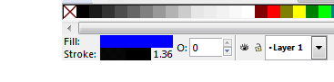
  - If you can’t see a shape or the color looks washed out check the alpha channel and set it to max,”255” 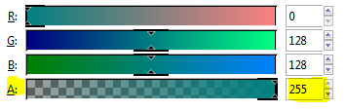

- When you have finished the project save the file in your folder.
  - Name the file: class_firstname_lastname_fill
- This is a Graded assignment
  - Daily grade
    - 50 points for following instruction
    - 50 points for naming the file and folder correctly
- Raise your hand.

