Project 3 Insperation
Jason T Johnson
University of Houston Clear Lake

When starting this project, I had a rough idea of the direction I wanted to go, I wanted to recreate a military vehicle from WW2. This would give me thousands of choices, and I could find a machine that I was excited to build, but also be within my skill level.
My initial thought was to go with a tank, and I searched the web for images of tanks that I would possibly enjoy building. After spending some time looking at pictures 3D renderings and other resource material I found myself becoming worried about how I would animate and create the world around the tank. The grass, the dirt, all the smoke and grit would take some considerable skill to achieve to a level I would be happy with. Because of these factors I began to change my mind on creating a ground vehicle. I have never been enamored with warships so I then turned my attention to the sky.
What to make; a fighter, a bomber, or close air support (CAS)? All sound intriguing and have their own qualities. There are iconic planes of all sorts from the war, so modeling the airplane would be fun no matter which direction that I chose. However, the animation was to be the deciding factor. As I did my research on air tactics, the death-defying dives of the CAS was what drew my attention. Then I had to decide on what type of CAS produce. The most iconic is the German Ju 87 “Stuka”, however I wanted to go with something from another of the allied nations. I looked at US P-47, but its design did not inspire me. I finally turned my attention to the Ilyushin IL-2 Sturmovik as seen in figure 1.
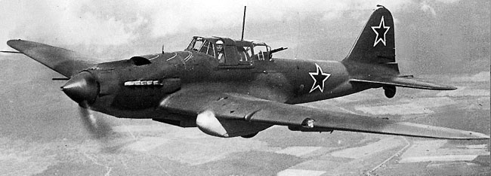
Figure 1. An example of a late ware IL-2M. Reprinted from Wikipedia, 2017 (https://en.wikipedia.org/wiki/Ilyushin_Il-2). In public domain.

After reading several articles about Russia’s most produced airplane of the war I had made my decision (Crellin, 2017; Roblin, 2017).
Having decided on the model I would build, I then scoured the internet for technical drawings and videos to get a better idea of the technical details of the IL-2. After looking over many technical drawings I decided I needed a more hands on example. I purchased a replica model from Ebay.com and a resource book from Amazon.com.
The final portion of planning for my animation was choosing the style. In my mind, I wanted to produce an animation with a grainy dated look. Something similar to stock war footage. I watch several Youtube.com videos to give me a deter feel for what I was looking for. I would like to include acurate sound effects and inspiring Russian music that would be an audio bed for my narration.

References
Crellin, E. (2017, March 22). Stalin’s “Essential Aircraft:” Ilyushin Il-2 in WWII. Retrieved September 19, 2017, from https://airandspace.si.edu/stories/editorial/stalin%E2%80%99s-ilyushin-il-2-shturmovik

Ilyushin Il-2. (2017, September 14). Retrieved September 19, 2017, from https://en.wikipedia.org/wiki/Ilyushin_Il-2

Roblin, S., Straub, D. G., Allen, J., O'Hanlon, M., & Goldstein, L. J. (2017, February 4). Russia's IL-2 Sturmovik 'Flying Tank': No Plane Has Been Built in Bigger Numbers (And It Helped Crush Hitler). Retrieved September 19, 2017, from http://nationalinterest.org/blog/the-buzz/russias-il-2-sturmovik-flying-tank-no-plane-has-been-built-19315

